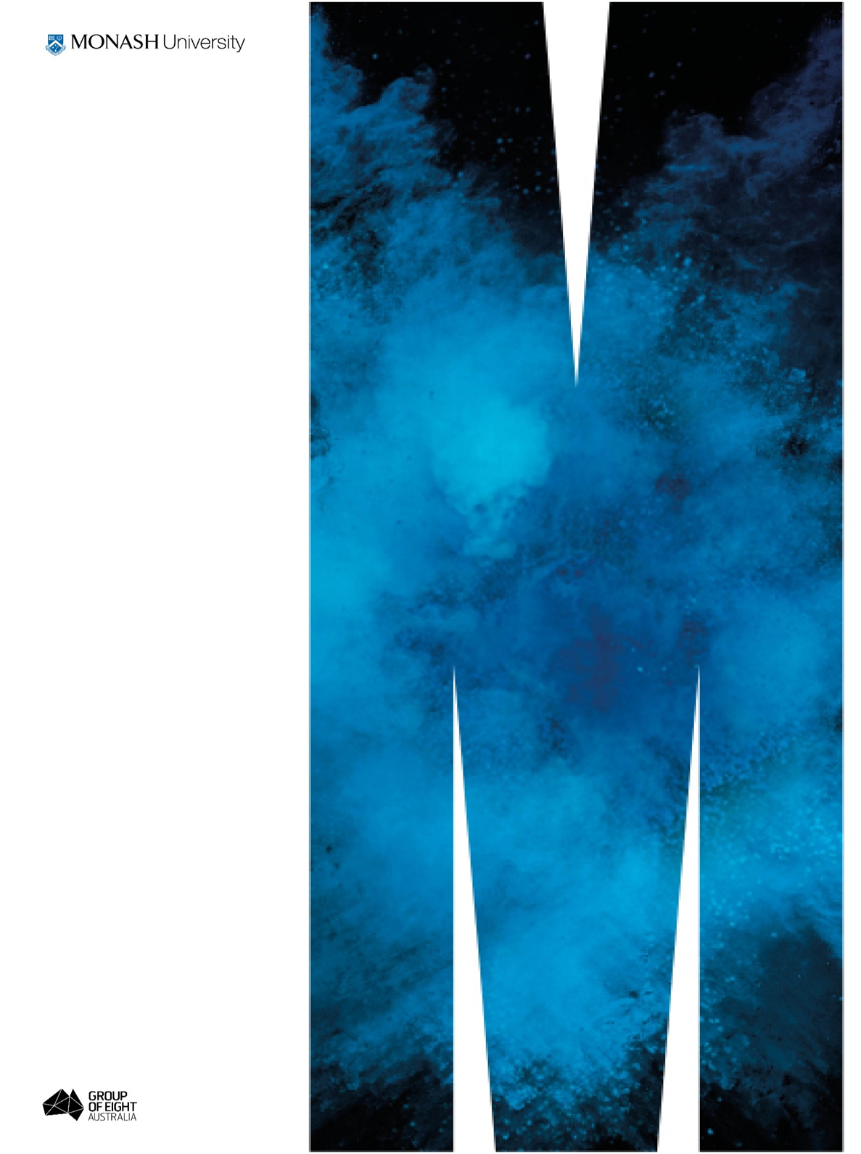
Identifying economic abuse amongst women with disability in Victoria: A toolkit for service providers and people affected by family violence
Final Report

Date: April 2019

Supported by the Victorian Women’s Benevolent Trust

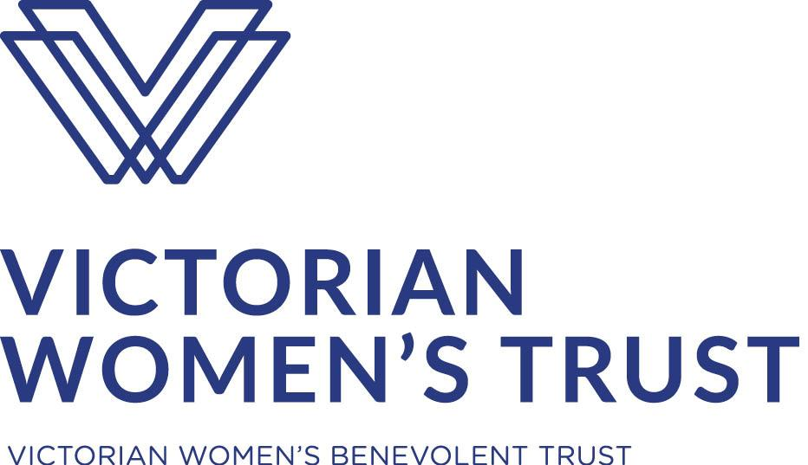
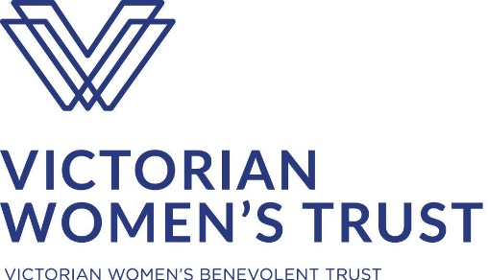

Identifying economic abuse amongst women with disability in Victoria: A toolkit for service providers and people affected by family violence

Final Report

The Monash Gender and Family Violence Prevention Centre in partnership with Tricia Malowney OAM. Supported by the Victorian Women’s Benevolent Trust.

April, 2019

Dr Jasmine McGowan
Professor JaneMaree Maher
Tricia Malowney OAM
Kate Thomas

Contact Details
Dr Jasmine McGowan
Centre Manager
Monash Gender and Family Violence Prevention Centre
W413 Menzies Building, 20 Chancellors Walk, Clayton Campus
Phone: (03) 9905 9434
Email: jasmine.mcgowan@monash.edu

Acknowledgments
The research team would like to thank the women who participated in the focus groups and final consultation as well as those who shared their stories with us for the original ANROWS-funded research upon which this project is based. We would also like to extend our thanks to the numerous stakeholders and experts who contributed so generously during the focus groups and afterwards.
We thank the Victorian Women’s Benevolent Trust for funding this project as part of their small grants program in 2018-2019. We would also like to acknowledge the ANROWS funding for Women Disability and Violence: Creating Access to Justice that began this work and we would like to thank members of the research team with whom we worked on this project, Dr Claire Spivakovsky and Professor Jude McCulloch from Monash University, Kara Beavis from Queensland University of Technology, and Dr Jessica Cadwallader, Meredith Lea and Therese Sands from People with Disability Australia.

Suggested Citation
McGowan, J., Maher, J.M., Malowney, T., & Thomas, K. (2019). Identifying economic abuse amongst women with disability in Victoria: A toolkit for service providers and people affected by family violence: Final Report. Melbourne: Monash Gender and Family Violence Prevention Centre.

Table of Contents
1. Acronyms 4
2. Executive summary 5
3. Introduction 7
3.1. Description and purpose of the toolkit 9
3.2. Current landscape 9
3.2.1. Economic and financial abuse 9
3.2.2. Domestic and family violence and women with disability 11
4. Process and development of toolkit 14
4.1. Initial development, focus groups and consultations 14
4.2. Accessible resources 14
5. References 16
6. Appendix 20
6.1. Appendix one - Pen portraits 20
6.2. Appendix two - Focus group organisations 25

Acronyms
ANROWS Australia’s National Research Organisation for Women’s Safety
DFV Domestic and family violence
MGFVPC Monash Gender and Family Violence Prevention Centre
NRAP National Risk Assessment Principles for domestic and family violence
RCFV Royal Commission into Family Violence
VWT Victorian Women’s Benevolent Trust

Executive summary
This project, Identifying economic abuse amongst women with disability in Victoria: A toolkit for service providers and people experiencing family violence draws on data collected for the Australia’s National Research Organisation for Women’s Safety funded project Women, disability and violence: Barriers to accessing justice (Maher et al., 2018). In that project researchers heard from 36 women in Victoria and New South Wales about their experiences seeking justice and safety in the context of family violence. Many of these women spoke specifically about economically coercive behaviours and the impact of this on their ability to secure safety. Researchers found a lack of awareness of the types of family violence perpetrated against women with disability and critically, a lack of accessible resources to assist in the identification of and support of women with disability to move away from such violence. In their final report researchers wrote that the ‘limited availability of resources for disability advocacy’ is a significant issue as these are ‘often a critical avenue for the disclosure of violence by people with disability’ (Maher et al., 2018, 31). The development of the toolkit for this project draws directly on the data gathered from these women.
Data on the prevalence of economic abuse is scarce. Experts point to the difficulty victims themselves have in ‘distinguishing economically abusive patterns from the economic insecurity they experience as women’ as central to this lack of evidence (Postmus et al., 2018, 2, 19). Emerging evidence does suggest that prevalence of economic abuse is high with Australian experts reporting that ‘[a]mong women who have sought help from domestic violence services, the prevalence of economic abuse ranges from 78% to 99%’ (Kutin, Russell, & Reid, 2017, 269). Despite being a widely under-recognised form of domestic and family violence, economic abuse is a ‘fundamental underpinning of coercive control’ consistently cited as exacerbating the dependence of victims on perpetrators and making it more difficult to leave violence (Postmus et al., 2018, 2). The Royal Commission into Family Violence found that ‘the lack of awareness and understanding of economic abuse among victims, the broader community and police, all contribute to women’s ongoing experiences of financial insecurity as a result of economic abuse’ (State of Victoria, 2016, 21, 118).
The Identifying Economic Abuse toolkit is intended to function as a referral toolkit and was designed with two key aims in mind. The first aim is to identify economic abuse where it is present and may have become normalised in the lives of women with disability and, as a consequence, raise awareness of this form of DFV amongst affected women, as well as within the service provision sectors supporting them. The second aim of the toolkit is to provide appropriate referral pathways and instigate, where necessary, information sharing.
Focus testing workshops for the toolkit were held with people with disability, experts and key stakeholders in late 2018. Additional feedback on both the toolkit and the referral resource was sought from experts and stakeholders following the workshops. The toolkit is intended for use by women with disability, specialist and mainstream support workers such as those in the health sector, as well as friends and support people. In order to reach the intended cohorts the toolkit has been developed in Plain English, Auslan and Easy English. A consultation was held with women with disability to test, refine and ensure the validity of the Plain English and image based Easy English translations of the toolkit in early 2019.

Introduction
In every treatment recovery plan there should be a tool on domestic violence that has to be asked...I think that'd be brilliant and I think it should be made mandatory. That's the first thing I thought of, looking through the tool I went wow. If I had sat down and done this I would have had takeaway paper to take with me and validate my experience as well. That would have been really good...one thing I'm looking at is trying to work out the next step for the financial abuse to stop basically….what I need now is...a support worker who will actually - whether it be temporarily case manage me to become financially independent...you need skills from services that specialise in that area so you can be seen through that lens rather than just a mental health or mental disability lens and I think it's a big difference.
Catherine - participant in Women, Disability and Violence (Maher et al., 2018)
This project, Identifying economic abuse amongst women with disability in Victoria: A toolkit for service providers and people experiencing family violence (‘the toolkit’), was funded by the Victorian Women’s Benevolent Trust (VWT) and was conducted and developed by researchers in the Monash Gender and Family Violence Prevention Centre (MGFVPC). The MGFVPC works toward the prevention of all types of family violence and aims to end family violence by building an evidence base to support those exposed to its harms and by challenging the attitudes and structures that underpin its perpetration. Following Victoria’s 2016 Royal Commission into Family Violence (RCFV) there has been both increased awareness of the prevalence of domestic and family violence (DFV) and increased understanding of the diverse groups at risk and in need of services and targeted resources.
The need for an instrument designed to support the identification of economic abuse amongst women with disability came about in the course of an earlier piece of research conducted by the MGFVPC, the Australia’s National Research Organisation for Women’s Safety (ANROWS) funded project Women, disability and violence: Barriers to accessing justice (Maher et al., 2018). In that project, Centre researchers spoke with 36 women with disability from urban and regional locations in Victoria and New South Wales and heard about their experiences of seeking justice and safety in the context of violence. The women described numerous forms of family violence, some explicitly referencing their experience of economically coercive behaviours and the impact of this on their ability to secure safety. The development of the toolkit for this project draws directly on the data gathered from these women. The stories used to develop the toolkit can be read in Appendix 1, built from the Pen Portraits of women who participated. The intended aim of the toolkit is to increase awareness of this often hidden form of family violence and assist women with disability to seek targeted support through appropriate referral pathways.
A key finding of Women, disability and violence was the issue of siloed knowledges across the specialist disability and family violence sectors. As part of the ANROWS project, Knowledge Translation and Exchange workshops were conducted with women with disability and sector service providers with the goal of ameliorating silos through the sharing of best practice approaches based on women with disability’s own knowledge of their needs. Research from both data collection and workshop phases of this project found a lack of awareness of the types of family violence perpetrated against women with disability and critically, a lack of accessible resources to assist in the identification of and support of women with disability to move away from such violence. As the authors of the report point out, the ‘limited availability of resources for disability advocacy’ is a significant issue as these are ‘often a critical avenue for the disclosure of violence by people with disability’ (Maher et al., 2018, 31; Victorian Government Department of Human Services, 2012, 35-36). Similar research has highlighted the importance of qualitative methods in increasing understanding and awareness of violence against women with disability (Vaughan, Devine, Diemer, & Jansen, 2018, 12). Such methods allow researchers to explore ‘disability-specific forms of violence’ which, in turn, can ‘contribute to the development of new or enhanced tools to measure the prevalence of the different forms of violence that women with disabilities ... face’ (Vaughan et al., 2018, 12).
Over the last seven years, a large amount of research focused on women with disability in the Australian context has been conducted and a clearer picture of disability-specific forms of DFV and its prevalence is now emerging (Maher et al., 2018). In order to secure ‘access to justice and freedom from violence’ for women with disability ‘it is clear that we need to act on what is known’ to create the conditions in which women with disability ‘have access to specialised violence services’ and those services have the resources to ‘facilitate access to specialised’ care and support (Maher et al., 2018, 10-11).
This project, and the development of an accessible toolkit designed to identify the specific forms of economic abuse faced by women with disability, is intended to contribute toward the dual goals of increasing awareness of disability-specific forms of violence and facilitating access to specialised support. The toolkit is a set of questions developed in Auslan, Plain English and Easy English using images designed to help women talk about economic abuse they may be experiencing, either on their own or with their support worker. It is hoped that tailored resources such as this toolkit will assist women and support workers in both specialist and mainstream contexts, to identify harm where it exists and seek appropriate responses to it. More broadly, it is also hoped that the development of such resources works to lessen the impact of siloed knowledges across the family violence, disability and health sectors.

Description and purpose of the toolkit
The Identifying Economic Abuse toolkit is not a risk assessment tool. It is intended to function as a referral toolkit and was designed with two key aims in mind. The first aim is to identify economic abuse where it is present and may have become normalised in the lives of women with disability and, as a consequence, raise awareness of this form of DFV amongst affected women, as well as within the service provision sectors supporting them. The second aim of the toolkit is to provide appropriate referral pathways and instigate, where necessary, information sharing.
While not a risk assessment tool per se, the discussion and information sharing prompted through the use of this toolkit may lead to the mobilisation of risk assessment processes. Therefore, it is hoped that the toolkit will contribute to the broader aims of risk assessment, namely, a shared understanding of economically abusive behaviours and risk amongst women with disability and service providers as well as targeted and effective referrals for women (Victorian Government Department of Human Services, 2012, 13; Backhouse and Toivonen, 2018, 8). In their review of the Common Risk Assessment Framework McCulloch et al. stress the importance of ‘building shared understandings of family violence’ (2016, 15). They contend that a shared ‘language of risk can...provide an effective means of communication between service providers and victim/survivors and be affirming and educative for victims of family violence’ (2016, 15; Backhouse and Toivonen, 2018, 8-9).

Current landscape

Economic and financial abuse
The National Risk Assessment Principles for domestic and family violence (NRAP) list ‘Financial violence’ as a type of DFV noting that all forms of DFV ‘are characterised by behaviours that are intended to coerce, control and/or create fear within an intimate or familial relationship’ (Backhouse and Toivonen, 2018, 7). Economic abuse became officially recognised in Victoria in the Family Violence Protection Act 2008 (Vic) following a review of DFV laws and the growing awareness ‘that violence does not need to be physical to keep victims living in fear’ (State of Victoria, 2016, 2, 15). The RCFV described economically abusive behaviours as those that ‘control a woman’s ability to acquire, use, and maintain economic resources’ thereby ‘threatening her economic security and potential for self-sufficiency’, adding that ‘economic vulnerability is further compounded by race, disability, age and sexuality’ (2016, 21, 93, 99).
Despite development in this area, a recent review of the global literature on economic abuse suggests that perceptions ‘of intimate partner violence…as constituting physical violence can still dominate, particularly in research and media reports’, and that as a consequence economic abuse remains a ‘frequently hidden or “invisible” form of abuse’ (Postmus et al., 2018, 1). Postmus et al. found a lack of definitional consistency and an absence of agreed upon measures for economic abuse and, while identifying a ‘growing clarity and consistency’ in these areas, they determined that the research is still in its ‘infancy’ (2018, 1). The authors highlight the lack of data on prevalence and point to the difficulty victims themselves have in ‘distinguishing economically abusive patterns from the economic insecurity they experience as women’, as central to this lack of evidence (Postmus et al., 2018, 2, 19). Despite being a widely under-recognised form of DFV, economic abuse is a ‘fundamental underpinning of coercive control’ consistently cited as exacerbating the dependence of victims on perpetrators and making it more difficult to leave violence (Postmus et al., 2018, 2). Emerging evidence does suggest that prevalence of economic abuse is high. In their analysis of economic abuse in Australia, Kutin et al. noted that ‘[e]conomic abuse is significantly associated with other forms of IPV (physical and psychological)’ and that ‘[a]mong women who have sought help from domestic violence services, the prevalence of economic abuse ranges from 78% to 99%’ (2017, 269). Similarly, the RCFV found that ‘[s]everal studies’ confirmed a pattern of the co-occurrence of economic abuse ‘in conjunction with psychological, emotional, physical and sexual abuse’ noting that ‘[o]ne s tudy found that 80 per cent of the 134 victims in the research group had experienced economic abuse’ (2016, 21, 95).
The first Scale of Economic Abuse (SEA) was developed in 2008 out of Michigan State University in the United States and included 120 items (Adams, Sullivan, Bybee, & Greeson, 2008). The SEA was revised and reduced to 12 questions in 2016 by Postmus, Plummer, & Stylianou (Postmus et al., 2018, 3). At that time, the authors defined the following ‘three conceptual categories’ of economic abuse: ‘economic control, economic exploitation, and employment sabotage’, and described tactics/affects such as ‘reduced access to savings and assets, deliberately causing housing insecurity by damaging property or not making rent or mortgage repayments, and malicious interference with workforce and educational participation’ (Postmus et al., 2018, 3, 2; see also Postmus, Plummer & Stylianou, 2016). In 2018, Postmus et al. note that the three conceptual areas have continued to structure contemporary literature on economic abuse (2018, 17). The term ‘financial abuse’ is also used to describe these abusive behaviours and is often used ‘interchangeably’ with economic abuse in current literature (Postmus et al., 2018; Sharp-Jeffs, 2015b). British economic abuse scholar Sharp-Jeffs makes a definitional distinction between financial abuse and economic abuse, suggesting that financial abuse is a part of economic abuse but designates behaviours specifically targeting ‘individual money and finances’ rather than ‘economic resources’, such as ‘transportation, a place to live, employment, and education’ (Postmus 2018, 2; Sharp-Jeffs 2015a).

Domestic and family violence and women with disability
Experiences of DFV amongst women with disability are distinctive and this is equally true in the context of economic abuse (Didi, 2016, 161; Healy, 2013; Maher et al., 2018). Research consistently indicates that when ‘gender and disability intersect’ experiences of violence tend to intensify in ‘frequency, extent and nature’ (Dowse et al., 2013, 17). Data indicates that ‘more than 70% of women with disabilities have been victims of violent sexual encounters’, women with disability ‘are 40% more likely to be the victims of domestic violence’, and ‘[w]omen with intellectual disabilities are at a “considerably heightened risk” of experiencing sexual assault compared with other women with disabilities’ (Frohmader and Sands, 2014, 1; Didi et al. 2016, 161; State of Victoria, 2016, 31, 173). Women’s experiences of violence will likely be exacerbated where additional aspects of diversity such as indigenous, socio-economic or immigration/refugee status, intersect with gender and disability (Maher et al., 2018; Didi et al., 2016, 160; Australian Law Reform Commission, 2010; Dowse et al., 2013). The support context in which care workers ‘are in a position to exert control and power’ mean that women with disability are exposed to more ‘potential perpetrators’ and situations of abuse than women without disability (State of Victoria, 2016, 31, 176-77; Didi, 2016, 160; Dowse et al., 2013). Research revealing the proliferation of violence encountered by people with disability within institutions has prompted scholars to describe the situation of women with disability as one of an ‘enhanced socio-relational vulnerabilit[y]’ (Didi et al., 2016, 161; also see Maher et al., 2018).
The RCFV reported that common forms of economic abuse include the control of ‘household finances [and] financial and utility accounts’ as well as the incursion of debt in the victim’s name through coercion or deception’ (State of Victoria, 2016, 21, 93). The Commission also cited perpetrators’ ‘use of joint assets’ as a means ‘to continue to exert control over their partner or former partner in the aftermath of violence’ (2016, 21, 93). Kutin et al. found the most common forms of economic abuse to be property damage and the destruction or stealing of property and that ‘[w]omen were ... more likely to experience economic partner abuse if they had a disability’ (2017, 271). They also noted, echoing the RCFV, that women may only become aware that they have been subject to economic abuse when they leave the relationship and the ‘process of financial settlement’ reveals the extent of the abuse that has preceded separation (2017, 271-2). Disability-specific DFV can include tactics such as controlling access to medication (either restricting or overdosing), communication or mobility aides, contraception (restricting or enforcing) and necessary care as well as violating privacy and threatening to institutionalise the person (Maher et al., 2018; also see Didi et al., 2016, 160; State of Victoria, 2016, 31, 177; Parliament of Australia 2015; Maher et al., 2018, 27). While the above tactics may all have economic inflections, disability-specific situations of economic abuse can also include official relationships including Powers of Attorney and Financial Trustee arrangements which can result in abuses of power (Maher et al., 2018; State of Victoria, 2016, 31, 177).
The data used to develop this toolkit, collected in the remit of the ANROWS-funded project, bears out the research cited above. The women with disability who participated in interviews and focus groups reported a variety of economically abusive behaviours including (Maher et al., 2018; see Pen Portraits Appendix 1):
- being denied access to their own money by intimate partners, and within formal arrangements such as Government Trustees;
- being provided an allowance from their own money;
- having their activities surveyed via intrusions on their personal devices;
- being in situations of financial precarity in relation to wills and property ownership;
- financial dependency due to visa status;
- unequitable spending of shared money such as an intimate partner buying expensive equipment or travelling overseas;
- employment sabotage and alternatively denial of disability in order to force women to work when they cannot or making them pay for tests to prove disability;
- delaying property settlement;
- forcing expensive legal proceedings; and
- intimate partners not contributing to mortgage repayments.
The RCFV found that economic abuse ‘is rarely identified as a form of family violence’ noting that official services and providers ‘do not consistently and appropriately recognise, intervene and respond to economic abuse...associated with post family violence’ (State of Victoria, 2016, 21, 118). The Commission noted that although it is not widely recognised, economic abuse ‘can be used as grounds to apply for an Intervention Order’ (State of Victoria, 2016, 2, 27). The Commission concluded ‘that the lack of awareness and understanding of economic abuse among victims, the broader community and police, all contribute to women’s ongoing experiences of financial insecurity as a result of economic abuse’ and further that there is as ‘opportunity to develop the capacity of...professionals to identify economic abuse and know what to do in response’ (State of Victoria, 2016, 21, 118). Postmus et al. call for interventions tailored to address economic abuse and call specifically for a focus in the practice setting writing (2018, 19):
Such focus should include ensuring that practitioners have the relevant knowledge and skills for assessing and responding to economic abuse, developing and testing interventions that address economic or financial abuse, and improving survivors’ economic security.
In her Churchill-funded research on economic abuse and best practice responses, Sharp-Jeffs recommended that ‘[r]esponses to financial abuse ... be mainstreamed into violence against women and girls’ services by making work to address women’s financial stability and independence a requirement within commissioning frameworks’ (2016, 7). A recent report produced by the Women’s Information and Referral Exchange (WIRE) in Victoria titled When’s the Right Time to Talk About Money (Fernando, 2018, 3) drew on data from hundreds of women who had accessed their service to explore ‘when, where and how women victim-survivors of family violence want to receive financial information and support’. The report found that, in general, women experience difficulty locating ‘information about financial issues’, that disability functions as a barrier to service provision and that ‘[d]isability services have different aims and objectives and women with disability cannot get support or pathways they need in one place’ (Fernando, 2018, 78, 57).

Process and development of toolkit

Initial development, focus groups and consultations
Researchers referred to Postmus, Plummer and Stylianou’s Scale of Economic Abuse - 12 (SEA- 12) (2016) when initially developing the Identifying Economic Abuse toolkit. Researchers then worked from data collected from women with disability through interviews and focus groups for the ANROWS funded project Women, disability and violence: Barriers to accessing justice (Maher et al., 2018). Interview and focus group transcripts were analysed for content related to economic abuse specifically. Relevant data was collated into the Pen Portraits, which were used to develop questions for the toolkit. This data can be viewed in Appendix One – Pen Portraits. An initial toolkit of 20 questions was developed based on this data.
Two focus testing workshops were scheduled for November 2018. The aim of the workshops was to focus test the toolkit with family violence and disability experts and key stakeholders. Researchers invited experts and key stakeholders to take part. The first focus test had 8 attendees and the second had 10 attendees. A list of participating organisations can be viewed in Appendix Two – Focus Group Organisations.
The focus testing workshops led to a final refinement of the toolkit to ten questions. Expert and stakeholder feedback was also sought after the workshops in the development of the referral toolkit.

Accessible resources
It is hoped that this toolkit will contribute to the project of increasing awareness of economic abuse, an often hidden form of family violence, and assist women with disability to seek targeted support through appropriate referral pathways. The toolkit has been designed for, and is targeted toward, both women with disability and service providers and support people. The toolkit is intended for use by women with disability, specialist and mainstream service providers such as those in the health sector, as well as friends and support people. In order to reach the intended cohorts that toolkit has been developed in Plain English, Auslan and Easy English.
Monash contracted an Easy English translation company, Need to Know Consultancy, to develop the Plain English and Easy English script with images, and The Deaf Society to develop the Auslan video. Monash consulted with women with disability after the competition of the Plain English and Easy English translation in order ensure the accessibility of the translations and validity of the toolkit.
Monash researchers have created a web resource for the toolkit where users can access the toolkit in PDF and accessible word format.
The complete referral toolkit is available on the website at: https://arts.monash.edu/gender-and-family-violence/research-projects/identifying-economic-abuse-amongst-women-with-disability-in-victoria/identifying-financial-abuse-amongst-women-with-disability. The final report and a short video about the project are also available on the website.

References
Legislation
Family Violence Protection Act 2008 (Vic)
Literature
Adams, A. E., Sullivan, C. M., Bybee, D., & Greeson, M. R. (2008). Development of the scale of economic abuse. Violence Against Women, 14, 563–588. doi:10.1177/1077801208315529
Australian Law Reform Commission. (2010). Family violence: A national legal response (ALRC 114 Summary). Retrieved from http://www.alrc.gov.au/sites/default/files/pdfs/publications/ Report Summary.pdf
Australia’s National Research Organisation for Women’s Safety. (2018). Women, Disability and Violence: Creating Access to Justice. Retrieved from https://www.anrows.org.au/project/women-disability-and-violence-creating-access-to-justice/
Australia’s National Research Organisation for Women’s Safety. (2018). Research Report: Women, Disability and Violence: Creating Access to Justice. Retrieved from https://www.anrows.org.au/publication/women-disability-and-violence-barriers-to-accessing-justice-final-report/
Australia’s National Research Organisation for Women’s Safety. (2018). National Risk Assessment Principles for family and domestic violence. Retrieved from https://www.anrows.org.au/research-program/national-risk-assessment-principles/
Backhouse, C., & Toivonen, C. (2018). National Risk Assessment Principles for domestic and family violence: Companion resource. A summary of the evidence-base supporting the development and implementation of the National Risk Assessment Principles for domestic and family violence (ANROWS Insights 09/2018). Sydney, NSW: ANROWS.
Didi, A., Soldatic, K., Frohmader, C., dowse, L. (2016). Violence against women with disabilities: is Australia meeting its human rights obligations?. Australian Journal of Human Rights. 22(1): 159-177.
Dowse, L., Soldatic, K., Didi, A., Frohmader, C., & van Toorn, G. (2013). Stop the violence: Addressing violence against women and girls with disabilities in Australia. Background Paper. Retrieved from http://researchdirect.westernsydney. edu.au/islandora/object/uws:36865
Fernando, N, (2018). When’s the right time to talk about money? Financial teachable moments for women affected by family violence. Melbourne: WIRE.
Fromader, C., and Sands, T. (2014). Fact Sheet: Violence against people with disabilities in institutions and residential settings. WWDA and PWDA [Online].
Healey, L. (2013). Voices against violence - Paper 2: Current issues in understanding and responding to violence against women with disabilities. Melbourne: Women With Disabilities Victoria.
Humphreys, C., Healey, L., & Diemer, K. (2015). The role of risk assessment and risk management in the response to family violence (Briefing paper 1). In Submissions from Professor Cathy Humphreys and research team: Submission to the Royal Commission into Family Violence Victoria. Melbourne: University of Melbourne.
Kutin, J., Russell, R., & Reid, M. (2017). Economic abuse between intimate partners in Australia: prevalence, health status, disability and financial stress. Australian and New Zealand Journal of Public Health, 41(3), 269-274. doi: 10.1111/1753-6405.12651
Maher, J. M., Spivakovsky, C., McCulloch, J., McGowan, J., Beavis, K., Lea, M., Cadwallader, J., & Sands, T. (2018). Women, disability and violence: Barriers to accessing justice: Final report (ANROWS Horizons, 02/2018). Sydney: ANROWS.
McCulloch, J., Maher, J., Fitz-Gibbon, K., Seagrave, M., & Roffee, J. (2016). Review of the Family Violence Risk Assessment and Risk Management Framework (CRAF), School of Social Sciences, Focus Program on Gender and Family Violence: New Frameworks in Prevention. Melbourne: Monash University.
Monash Gender and Family Violence Prevention Centre. (2018). Identifying economic abuse amongst women with disability in Victoria. Retrieved from https://arts.monash.edu/gender-and-family-violence/research-projects/identifying-economic-abuse-amongst-women-with-disability-in-victoria
Monash Gender and Family Violence Prevention Centre. (2019). Identifying economic abuse amongst women with disability in Victoria: A toolkit. Retrieved from https://arts.monash.edu/gender-and-family-violence/research-projects/identifying-economic-abuse-amongst-women-with-disability-in-victoria/identifying-financial-abuse-amongst-women-with-disability
Monash Gender and Family Violence Prevention Centre. (2019). Monash Gender and Family Violence Prevention Centre. Retrieved from https://arts.monash.edu/gender-and-family-violence/home
Monash Gender and Family Violence Prevention Centre. (2018). Women, Disability and Violence: Knowledge Translation and Exchange Workshop. Retrieved from https://arts.monash.edu/gender-and-family-violence/research-projects/completed-projects/women,-disability-and-violence/women,-disability-and-violence-knowledge-translation-and-exchange-workshop
Parliament of Australia. (2015). Violence, abuse and neglect against people with disability in institutional and residential settings, including the gender and age related dimensions, and the particular situation of Aboriginal and Torres Strait Islander people with disability, and culturally and linguistically diverse people with disability. Retrieved 11 April 2017 from: https://www.aph.gov.au/Parliamentary_Business/Committees/Senate/Community_Affairs/Violence_abuse_neglect/Report
Postmus, J. L., Plummer, S. B., & Stylianou, A. M. (2016). Measuring economic abuse in the lives of survivors: Revising the Scale of Economic Abuse. Violence Against Women, 22, 692–703. doi:10.1177/1077801215610012.
Postmus, J., Hoge, G., Breckenridge, J., Sharp-Jeffs, N., & Chung, D. (2018). Economic Abuse as an Invisible Form of Domestic Violence: A Multicountry Review. Trauma, Violence, & Abuse, Online first, 1-23. doi:10.1177/1524838018764160
Royal Commission into Family Violence . (2019). Report and Recommendations. Retrieved from http://www.rcfv.com.au/Report-Recommendations
Sharp-Jeffs, N. (2015a). Money matters: Research into the extent and nature of financial abuse within intimate relationships in the UK. London, England: The Co-operative Bank/Refuge.
Sharp-Jeffs, N. (2015b). A review of research and policy on financial abuse within intimate partner relationships. London, England: Child and Woman Abuse Studies Unit, London Metropolitan University.
Sharp-Jeffs, N. (2016). Supporting Survivors of Financial Abuse: Learning for the UK. (Winston Churchill Memorial Trust Fellowship Report). Retrieved from https://www.wcmt.org.uk/sites/default/files/report-documents/Sharp%20N%20Report%202016%20Revised.pdf
State of Victoria. (2014–16). The nature, dynamics and effects of family violence. Royal Commission into Family Violence: Summary and recommendations, Parl Paper No 132. 2: 15-46.
State of Victoria. (2014–16). Financial Security. Royal Commission into Family Violence: Summary and recommendations, Parl Paper No 132. 21: 93-133.
State of Victoria. (2014–16). People with Disabilities. Royal Commission into Family Violence: Summary and recommendations, Parl Paper No 132. 31: 167-203.
Vaughan, C., Devine, A., Diemer, K., & Jansen, H. (2018). Measuring the prevalence of violence against women with disabilities (Summary report from a kNOwVAWdata initiative consultation 18th October 2017, Canberra). Retrieved from https://asiapacific.unfpa.org/sites/default/files/pub-pdf/kNOwVAWdata%20Disability%20Consultation%20report%20-%2023Feb2018.pdf
Victorian Government Department of Human Services. (2012). Family Violence Risk Assessment and Risk Management Framework and Practice Guides 1-3, Edition 2. Melbourne, Australia. Retrieved from https://providers.dhhs.vic.gov.au/sites/dhhsproviders/files/2017-06/family-violence-risk-assessment-risk-management-framework-practice-guides.PDF
Victorian Women’s Benevolent Trust. (2018). Identifying economic abuse amongst women with disability in Victoria. Retrieved from https://www.vwt.org.au/grant/identifying-economic-abuse-amongst-women-with-disability-in-victoria-a-toolkit-for-service-providers-and-victim-survivors/

Appendix

Appendix one - Pen portraits
Hannah
45-50 years old, English speaking background
Hannah was the victim of a home invasion during which she experienced sexual assault. Her property was damaged and she was robbed. Prior to the attack Hannah had been subject to ongoing abuse and harassment from a number of families living in the same suburb. Hannah had recently bought a new car and she believes this visibility may have made her a target. Hannah has some money that is in the control of the Government Trustees. Hannah has a difficult relationship with the Trustees who either deny or make it difficult for her to use the money. Hannah feels as though she has to justify her requests for money and purchases to a degree that is not appropriate. For example, Hannah has to justify her requests for items such as curtains and a pet dog. She has been told by the Trustees to ‘save up’ for the curtains. Hannah considers the curtains to be a basic need and feels that living without them compromises her security.
I’d like a dog, not so much as a guard dog or anything, just like a therapy dog...that’d keep me company and will kind of protect me and will let me know that there’s someone at the door. Or someone’s out in the back yard or something. Because my hearing is getting worse and so that I think would help me enormously. And for company too...But the Trustees won’t give me the money to do that, even though I have the money. See, I notice with them – and they don’t care about the rape or anything. They couldn’t care less. And if they see that you are happy and you are comfortable, they hate that. And I do want the dog, very, very much so. And I've been saying that for years.
Cherie
50-55 years old, English speaking background
Cherie and her husband have been married for about two decades. Cherie’s husband behaves in a coercively controlling way toward her subjecting her to verbal and financial abuse. Cherie’s husband denies her access to money, including her own, and provides her with an allowance, using her ABI as a justification. He does not allow her to have a house key. He surveys her activities and movements by checking her personal devices, for example by reading the diary on her ipad. Cherie feels she is in a financially precarious situation. When Cherie discusses the idea of her future financial security it is contingent on her husband having passed away.
For me, what happens is financial, big control of the money. I get an allowance, and I’m the biggest earner. Verbal, name-calling. Not yelling, as such, but a very loud boisterous voice. Control. I don’t even have a front door key.
Renee
30-35 years old, from South East Asia, migrant to Australia
Renee is a migrant to Australia and does not have permanent residency status. She has a young daughter. Renee is financially dependent on her mother and has little to no autonomy. Renee feels she no control over her own and her daughter’s circumstances.
Nadine
50-60 years old, English speaking background
Nadine is separated from her husband of about two decades. They have a daughter.
Nadine’s husband used controlling behaviours throughout their marriage including sexual coercion. He did not share parenting duties. Nadine was also subject to long term financial abuse. Nadine’s husband spent a lot of money on expensive things while restricting Nadine’s spending. He knowingly allowed her to use a damaged and dangerous motorized chair for years.
Nadine and her husband are in dispute over their property. He has stopped contributing to the mortgage and Nadine believes he is delaying settlement in order to drive the property price up.
And my husband, looking back, had always been abusive and controlling. Sort of a power and control, constant. But I had lived with it and coped with it and everything and knew what I had to do.
Leah
30-40 years old, English speaking background
Leah experienced domestic violence and abuse from her partner and then husband of two and half years. Leah and her husband had two foster children. The children are no longer in Leah’s care. Leah’s husband took out five credit cards in her name and accrued $40,000 of debt. After separation Leah was declared bankrupt. They had been separated for seven years when we spoke with Leah and she was still paying off the debt and having difficulty getting her financial life back on track.
Leah: The fact that he took about five credit cards and he took – like, my credit rating’s crap. I can’t get any decent loans for a car for instance and just take away independence. That’s the worst part really. When they take all that away from you it’s just like you feel helpless but hopefully I'm getting a car again and I’ll gain all that back again.
Leah: See, this is the thing. I could have gone to the police but knowing that, you’re scared because you think if you go the police and speak up, if he knew about it, he would have decked me. He would have hit me or he would have decked me.
Celia
45-50 years old, English speaking background
The abuse of Celia by her father began in childhood and has continued into her adult life. Celia’s father has perpetrated physical, sexual and financial abuse against her. Celia lives on her own in a property that she rents off her parents. Celia has a mental illness and has accessed support from psychiatric services. Celia’s father has told health workers and members of Celia’s family that the abuse is all in Celia’s head.
Sonia
40-45 years old, English speaking background
Sonia was married to her ex-husband for over 10 years. They have children. Sonia’s ex-husband also has a disability and he was Sonia’s carer. Throughout their marriage he physically and sexually abused Sonia. Sonia eventually disclosed the abuse to hospital staff. Child protection was called in and her husband was removed from the home. It was eight weeks before Sonia received a referral for some in-home support services and the referral was only prompted because Sonia told Child Protection that she was going to ask her ex-husband to return home to help her. Once supports were in place Sonia was able to see clearly his behaviour and the patterns of abuse. Sonia could not conceptualise how she could support herself without him before this. She says she was ‘made independent by external services.’
...growing up with a disability, you’re always relying on other people just to do stuff for you, other people - you’ve never really made to feel empowered to be independent and do things for yourself.
When you’re told things growing up - that it’s going to take somebody really special to marry you and take you on and to care for you - then when that person comes along, you go, I need to hold onto this person because it’s going to take somebody special to want to be with me. This somebody special’s come along, I’d better not lose them. There’s all these little things that you're told all your life that just make you vulnerable; vulnerable to somebody who is going to perpetrate family violence or to be stuck in a relationship that is violent. It just makes us so incredibly vulnerable.
Wanda
30-40 years old, English speaking background
Wanda experienced verbally abusive and obsessive behaviours from a male flatmate she once shared a house with. The flatmate stole and damaged her property. Wanda sought help from a disability advocate and the police regarding the stolen property. She was reluctant to tell her family about the abuse as she was trying to prove to them that she could live independently and that they didn’t need to worry about her. This pressure meant that Wanda put up with a bad situation longer than she would have liked.
It’s like when I have told people before about having to live in this place for months and being scared of being there and having to lock my door and message people and stuff like that and making sure that I’m safe and stuff and they’re like ‘why didn’t you just leave?’ and my main reason and to some it might sound stupid but it was because I didn’t want to break my lease because I’d just moved out of home and I’m like – if I break a lease I don’t have a good track record. I’ve got a disability, it’s hard enough for me to be able to get a private rental with having a wheelchair and having a place that’s got access and then having the landlord or whoever to sign off on the rental agreement that it’s been okay with somebody in a wheelchair living in their property and all the rest of it.
… and yes I know if I had have said something to, you know, a family member, they probably would have given me money and all the rest of it. But my whole point of me moving out of home was to prove that I could do it and be independent and all the rest of it.
Rose
40-50 years old, European-Australian
Rose has an ABI from a traffic accident and is involved on an ongoing court case in relation to the accident and the damages. Rose has problems with her memory and spoke about ongoing psychological abuse in the form of people lying to her and keeping information from her. Rose feels exclude from the processes of the court case and suspects financial abuse of some sort.
Isolation. It feels very lonely, like you can’t trust anyone and when you do, that often hits you in the face as well; so better not to. Which leaves you in a completely alone place, always and I believe it has a lot to do with my disability. Because of the memory issues involved with it, people just take advantage of that so much.
Kristina
40-50 years old, English speaking background
Kristina’s father subjected her to severe physical and psychological violence during her childhood. Kristina also experienced sexual abuse from a male relative when she was a child. As an adult Kristina has been subject to sexual abuse from a boarding house proprietor as well as other men. Kristina became pregnant from another man and was coerced into having the baby. She subsequently gave it up for adoption.

Appendix two - Focus group organisations
Domestic Violence Resource Centre Victoria
National Disability Services
Outlook
Reinforce
Scope
South Eastern Centre Against Sexual Assault
Unaffiliated – disability support worker – Diploma of Community Services candidate
Victorian Legal Aid
Victorian Police – Centre for Family Violence
Victoria Police – Family Violence Command
Women with Disability Victoria
Women with disability consulted with Monash researchers and have requested to remain anonymous

